**Create a dockerfile, docker-compose file which when executed must display your basic details in the website.**

**Steo 01:** Created a folder and added Python, Dockerfile, requirements, and Docker Compose files within it.

**Step 02:** Creating a python file

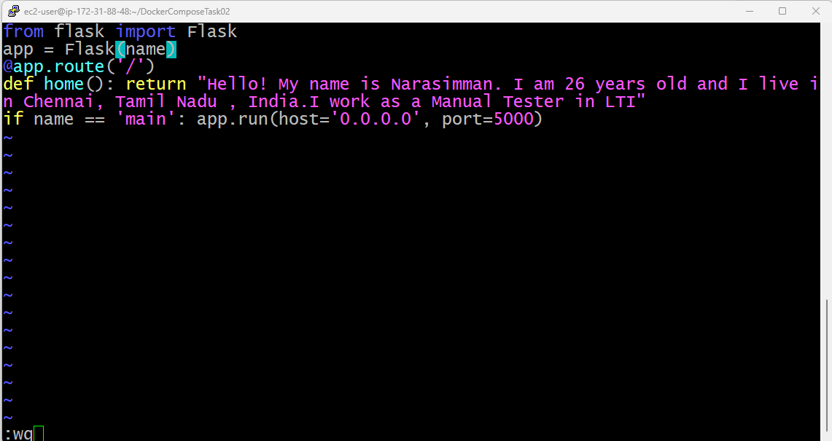

**Step 02:** Creating a requirement text file

**Step 03:** Docker file creation

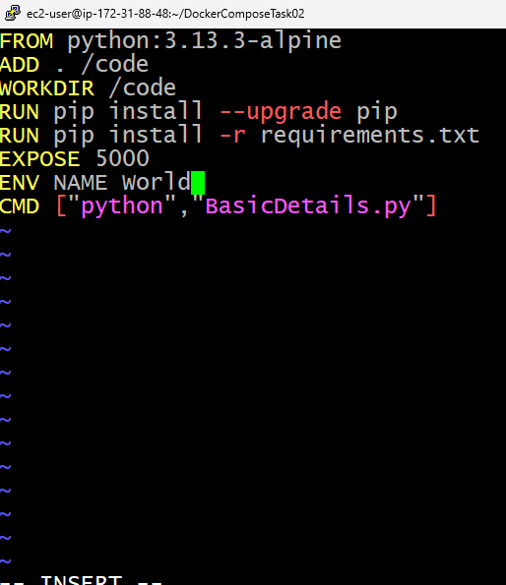

**Step 04:** Docker compose file creation

All the files have been created successfully

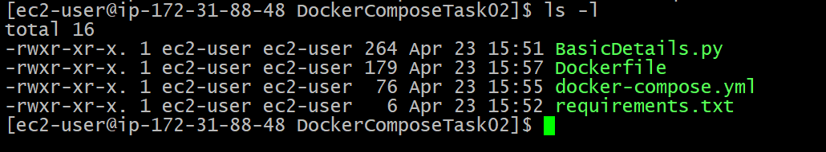

**Step 05:** Build and run your containers

**Step 06:** Basic Details

